**Report for Dice Game**

**Question1:**

The FSM of the flow chart is as follows

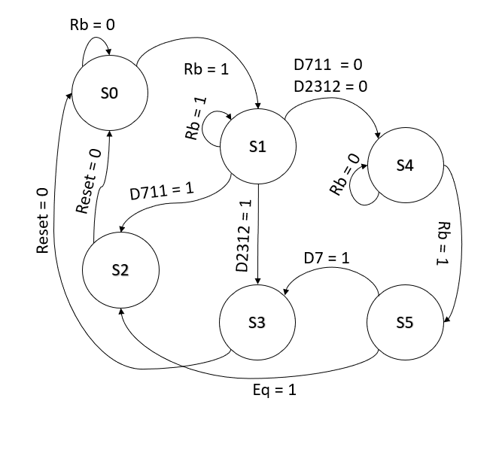

**Question 2:**

The Simulation are as follows:

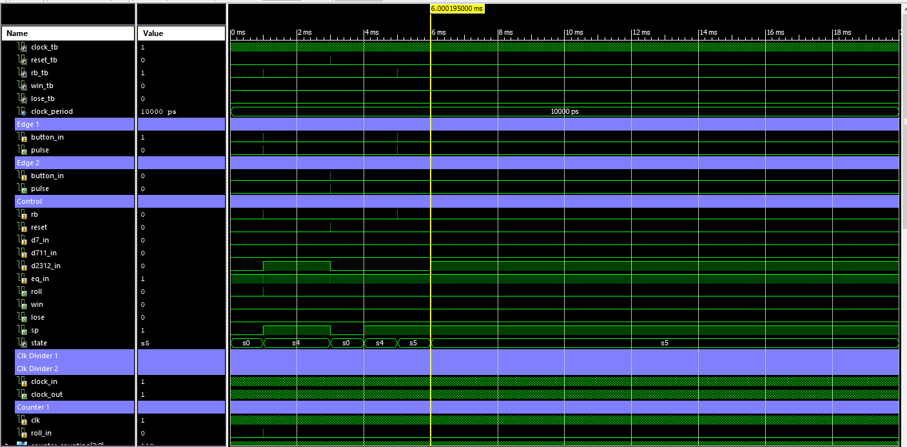

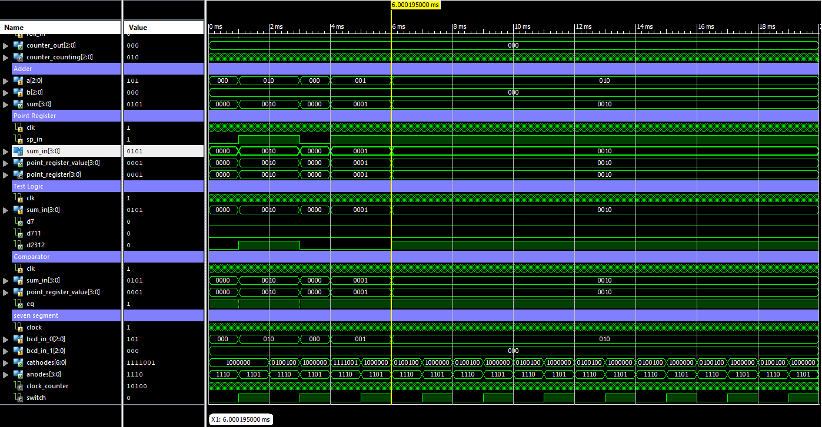

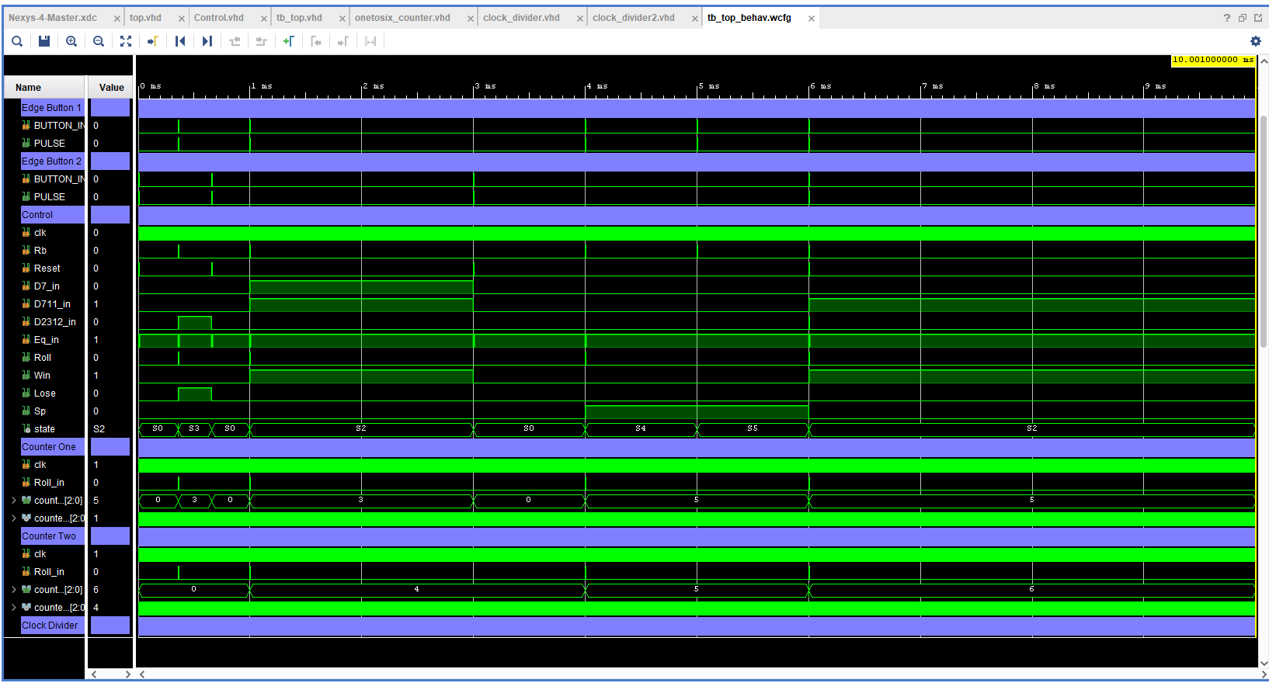

Win and Lose conditions

The Top Module is as follows:

|  |
| --- |
| ----------------------------------------------------------------------------------  -- Company:  -- Engineer:  --  -- Create Date: 21:32:06 10/25/2024  -- Design Name:  -- Module Name: top - Behavioral  -- Project Name:  -- Target Devices:  -- Tool versions:  -- Description:  --  -- Dependencies:  --  -- Revision:  -- Revision 0.01 - File Created  -- Additional Comments:  --  ----------------------------------------------------------------------------------  library IEEE;  use IEEE.STD_LOGIC_1164.ALL;  -- Uncomment the following library declaration if using  -- arithmetic functions with Signed or Unsigned values  use IEEE.NUMERIC_STD.ALL;  -- Uncomment the following library declaration if instantiating  -- any Xilinx primitives in this code.  --library UNISIM;  --use UNISIM.VComponents.all;  entity top is  Port(  clock : in std_logic;  Reset : in std_logic;  Rb : in std_logic;  Win : out std_logic := '0';  Lose : out std_logic := '0';  cathodes_out : out std_logic_vector(6 downto 0) := (others => '0');  anodes_out : out std_logic_vector(3 downto 0) := (others => '1')  );  end top;  architecture Behavioral of top is  component Edge_Detector  Port(  CLK_SYS : in std_logic;  BUTTON_IN : in std_logic;  PULSE : out std_logic  );  end component;    component Control is  Port(  clk : in std_logic;  Rb : in std_logic;  Reset : in std_logic;  D7_in : in std_logic;  D711_in : in std_logic;  D2312_in : in std_logic;  Eq_in : in std_logic;  Roll : out std_logic;  Win : out std_logic;  Lose : out std_logic;  Sp : out std_logic  );  end component;    component onetosix_counter  Port(  clk : in std_logic;  reset : in std_logic;  Roll_in : in std_logic;  counter_out : out std_logic_vector(2 downto 0)  );  end component;    component clock_divider is  generic(  FPGA_CLK_FREQUENCY : integer := 100000000;  REQUIRED_FREQUENCY : integer := 50000000  );  Port (  clock_in : in STD_LOGIC;  clock_out : out STD_LOGIC  );  end component;    component Adder  Port (  A : in STD_LOGIC_VECTOR(2 downto 0); -- 4-bit input A  B : in STD_LOGIC_VECTOR(2 downto 0); -- 4-bit input B  SUM : out STD_LOGIC_VECTOR(3 downto 0) -- 5-bit Sum Output  );  end component;    component point_register  Port(  clk : in STD_LOGIC;  Sp_in : in STD_LOGIC;  SUM_IN : in std_logic_vector(3 downto 0);  point_register_value : out std_logic_vector(3 downto 0)  );  end component;    component comparator  Port(  clk : in std_logic;  sum_in : in std_logic_vector(3 downto 0);  point_register_value : in std_logic_vector(3 downto 0);  Eq : out std_logic  );  end component;    component Test_Logic  Port(  clk : in std_logic;  sum_in : in std_logic_vector(3 downto 0);  D7 : out std_logic;  D711 : out std_logic;  D2312 : out std_logic  );  end component;    component bcdto7seg  Port (  clock : in std_logic;  bcd_in_0 : in std_logic_vector (2 downto 0);  bcd_in_1 : in std_logic_vector (2 downto 0);  cathodes : out std_logic_vector (6 downto 0);  anodes : out std_logic_vector(3 downto 0)  );  end component;    signal start_button : std_logic := '0';  signal reset_button : std_logic := '0';  signal Roll_out : std_logic := '0';  signal Win_out : std_logic := '0';  signal Lose_out : std_logic := '0';  signal counter_one_out : std_logic_vector(2 downto 0) := (others => '0');  signal counter_two_out : std_logic_vector(2 downto 0) := (others => '0');  signal clock_divided_1 : std_logic := '0';  signal clock_divided_2 : std_logic := '0';  signal Sum_out : std_logic_vector(3 downto 0) := (others => '0');  signal point_register_val : std_logic_vector(3 downto 0) := (others => '0');  signal Eq_out : std_logic := '0';  signal D7_out : std_logic := '0';  signal D711_out : std_logic := '0';  signal D2312_out : std_logic := '0';  signal Sp_out : std_logic := '0';  begin    uut : Edge_Detector  port map(  CLK_SYS => clock,  BUTTON_IN => Rb,  PULSE => start_button  );    uut2 : Edge_Detector  port map(  CLK_SYS => clock,  BUTTON_IN => Reset,  PULSE => reset_button  );    uut3 : Control  port map(  clk => clock,  Rb => start_button,  Reset => reset_button,  D7_in => D7_out,  D711_in => D711_out,  D2312_in => D2312_out,  Eq_in => Eq_out,  Roll => Roll_out,  Win => Win,  Lose => Lose,  Sp => Sp_out  );    --uut4 : clock_divider  --generic map(  -- FPGA_CLK_FREQUENCY => 100000000,  -- REQUIRED_FREQUENCY => 100000000  --)  --port map(  -- clock_in => clock,  -- clock_out => clock_divided_1  --);    uut5 : onetosix_counter  port map(  clk => clock,  reset => reset_button,  Roll_in => Roll_out,  counter_out => counter_one_out  );    uut6 : clock_divider  generic map(  FPGA_CLK_FREQUENCY => 100000000,  REQUIRED_FREQUENCY => 50000000  )  port map(  clock_in => clock,  clock_out => clock_divided_2  );    uut7 : onetosix_counter  port map(  clk => clock_divided_2,  reset => reset_button,  Roll_in => Roll_out,  counter_out => counter_two_out  );    uut8 : Adder  port map(  A => counter_one_out,  B => counter_two_out,  SUM => Sum_out  );    uut9 : point_register  port map(  clk => clock,  Sp_in => Sp_out,  SUM_IN => Sum_out,  point_register_value => point_register_val  );    uut10 : comparator  port map(  clk => clock,  sum_in => Sum_out,  point_register_value => point_register_val,  Eq => Eq_out  );    uut11 : Test_Logic  Port map(  clk => clock,  sum_in => Sum_out,  D7 => D7_out,  D711 => D711_out,  D2312 => D2312_out  );    uut12 : bcdto7seg  Port map (  clock => clock,  bcd_in_0 => counter_one_out,  bcd_in_1 => counter_two_out,  cathodes => cathodes_out,  anodes => anodes_out  );      end Behavioral; |

**Question 3:**

The Constraint Requirements for the FPGA of Nexys 3 are as follows:

|  |
| --- |
| ## This file is a general .ucf for Nexys3 rev B board  ## To use it in a project:  ## - remove or comment the lines corresponding to unused pins  ## - rename the used signals according to the project  ##Clock signal  Net "clock" LOC=V10 | IOSTANDARD=LVCMOS33;  ## 7 segment display  Net "cathodes_out(0)" LOC = T17 | IOSTANDARD = LVCMOS33; #Bank = 1, pin name = IO_L51P_M1DQ12, Sch name = CA  Net "cathodes_out(1)" LOC = T18 | IOSTANDARD = LVCMOS33; #Bank = 1, pin name = IO_L51N_M1DQ13, Sch name = CB  Net "cathodes_out(2)" LOC = U17 | IOSTANDARD = LVCMOS33; #Bank = 1, pin name = IO_L52P_M1DQ14, Sch name = CC  Net "cathodes_out(3)" LOC = U18 | IOSTANDARD = LVCMOS33; #Bank = 1, pin name = IO_L52N_M1DQ15, Sch name = CD  Net "cathodes_out(4)" LOC = M14 | IOSTANDARD = LVCMOS33; #Bank = 1, pin name = IO_L53P, Sch name = CE  Net "cathodes_out(5)" LOC = N14 | IOSTANDARD = LVCMOS33; #Bank = 1, pin name = IO_L53N_VREF, Sch name = CF  Net "cathodes_out(6)" LOC = L14 | IOSTANDARD = LVCMOS33; #Bank = 1, pin name = IO_L61P, Sch name = CG  #Net "cathodes_out(7)" LOC = M13 | IOSTANDARD = LVCMOS33; #Bank = 1, pin name = IO_L61N, Sch name = DP  Net "anodes_out(0)" LOC = N16 | IOSTANDARD = LVCMOS33; #Bank = 1, pin name = IO_L50N_M1UDQSN, Sch name = AN0  Net "anodes_out(1)" LOC = N15 | IOSTANDARD = LVCMOS33; #Bank = 1, pin name = IO_L50P_M1UDQS, Sch name = AN1  Net "anodes_out(2)" LOC = P18 | IOSTANDARD = LVCMOS33; #Bank = 1, pin name = IO_L49N_M1DQ11, Sch name = AN2  Net "anodes_out(3)" LOC = P17 | IOSTANDARD = LVCMOS33; #Bank = 1, pin name = IO_L49P_M1DQ10, Sch name = AN3  ## Leds  Net "Win" LOC = U16 | IOSTANDARD = LVCMOS33; #Bank = 2, pin name = IO_L2P_CMPCLK, Sch name = LD0  Net "Lose" LOC = V16 | IOSTANDARD = LVCMOS33; #Bank = 2, pin name = IO_L2N_CMPMOSI, Sch name = LD1  ## Switches  Net "Rb" LOC = T10 | IOSTANDARD = LVCMOS33; #Bank = 2, pin name = IO_L29N_GCLK2, Sch name = SW0  Net "Reset" LOC = T9 | IOSTANDARD = LVCMOS33; #Bank = 2, pin name = IO_L32P_GCLK29, Sch name = SW1 |

These includes 2 switches, 2LED and 2 seven segments which are refreshing at 1ms response time.